Architecture Comparison and VMX Configuration Experiment

DYLAN FAHR

6/19/16

**Table of Contents**

**Executive Summary …………………………………………………………………. 2**

**Status of the Machines ……………………………………………………………… 3 - 8**

**Experiment Results and Data ……………………………………...................................... 9 - 35**

**Analysis and Comparison of Results**

**…………………….…....................................................... 36 - 37**

**Configuration Changes ………...…………………………………………………. 38 - 41**

**Conclusion ………………………………………………………....... 42 - 43**

**Executive Summary**

This experiment serves to compare two type 2 hypervisors and their performance in regards to virtualization and the functionality of the virtual machine. Two copies of the same virtual machine will be used in two type 2 hypervisors and be tested through a series of benchmark tests in order to test the limits and performance of the virtual machines within the hypervisors.

The end goal of the experiment is to have a more direct conclusion of which type 2 hypervisor tested is superior in performance and functionality in terms of virtualization. To obtain this goal, both virtual machines will be of the same operating system and be subjected to similar benchmark tests. The host system will also be benchmarked and analyzed in order to detect any additional performance issues or changes that result from the experiment.

Operating Systems Used:

* Host: Windows 10 64 bit
* Virtual Machines: Windows 7 x64

Virtual Machine Software:

* VMware Workstation Pro 12
* Oracle VM Virtual Box 5.0.22

Benchmarking Software Used:

* NovaBench
* Speedtest.net (network benchmark)

Metrics Tested:

* CPU processing and power
* GPU processing and Power
* RAM Transfer Speeds
* Drive Write Speed
* Network Speed (Ping)

Misc. Software:

* Speccy (for machine status Screen shots)

Conclusion:

In conclusion, there are differences in performance of the two type 2 hypervisors, Virtual Box and VMware Workstation. Results from benchmark tests and status screenshots help determine which type 3 hypervisor is superior in performance and which can be utilize more of the metrics provided from the host system. Additionally, it should be noted that the makeup of the configuration file of the type 2 hypervisor was tested and edited to see what would cause failure and what would reverse the effects. Findings of that additional experiment and conclusions of which hypervisor is superior in performance is provided within the report and should be noted accordingly when reaching a determination of superiority between the two tested.

**Machine 1 (Host System):**

System Summary:

Windows 10 Pro System

CPU: Intel Core i5 4690K @ 3.50GHz Haswell 22nm Technology

RAM: 8.00GB Single-Channel DDR3 @ 799MHz (11-11-11-28)

Motherboard: MSI Z97 PC Mate(MS-7850) (SOCKET 0)

Storage: 931GB TOSHIBA HDWD110 (SATA)

Optical Drive: TSSTcorp CDDVDW SH-224FB

CPU:

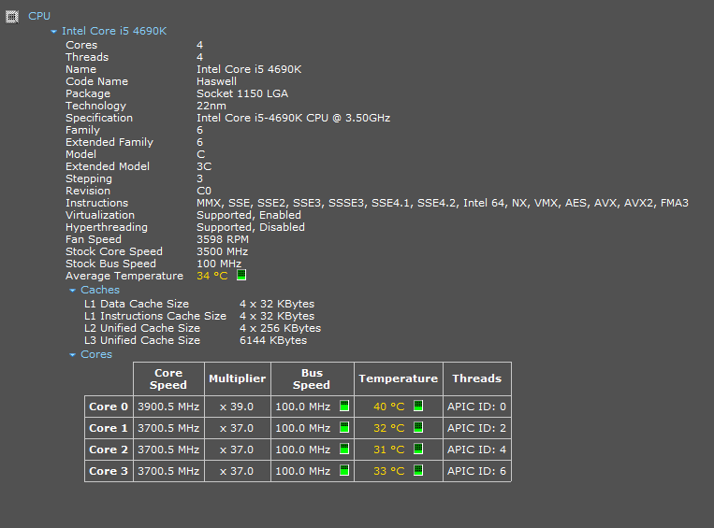

Memory:

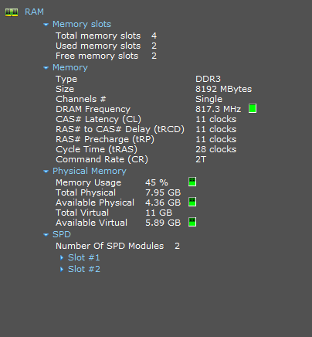

Storage:

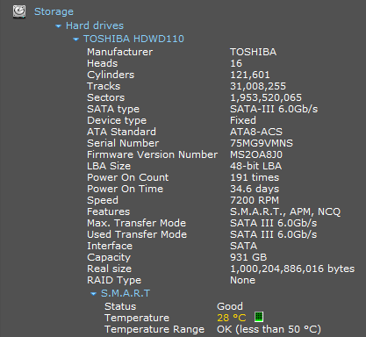

**Windows 7 VM:**

System Summary:

Windows 7 Home Basic 64-bit SP1

CPU:  
Intel Core i5 @ 3.50GHz  
Haswell 22nm Technology

RAM:  
4.00GB EDO @ 66MHz (3-3-3-?)

Motherboard:  
Intel Corporation 440BX Desktop Reference Platform (CPU #000)

Graphics:  
Generic Non-PnP Monitor (1024x768@60Hz)  
VMware SVGA 3D (VMware)

Storage:  
60GB VMware, VMware Virtual S SCSI Disk Device (SAS(Serial Attached SCSI))

Optical Drives:  
NECVMWar VMware SATA CD01 ATA Device

CPU:

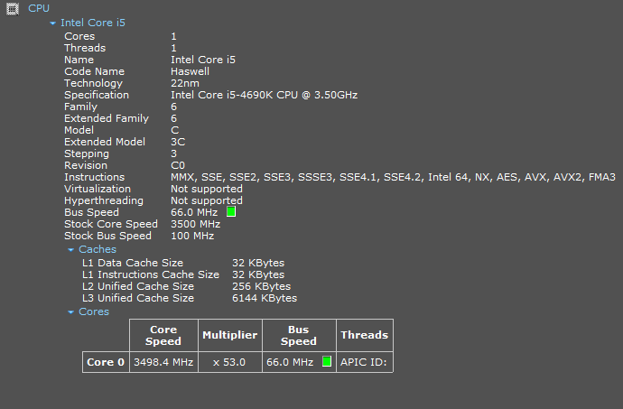

Memory:

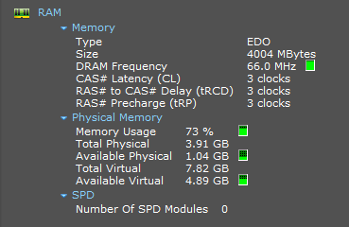

Storage:

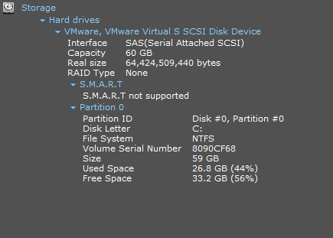

**Host System Status and Benchmark Results (Before running either VMware Workstation or Virtual Box):**

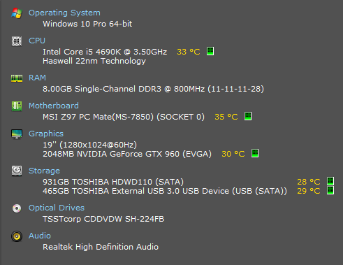

CPU Benchmark:

The CPU of the host system was benchmarked through the use of NovaBench, where the speed, power, and efficiency of the CPU was tested through three separate tests. The tests that were conducted on the CPU were floating point operations calculated per second, integer operations calculated per second, and MD5 hashes generated per second. By running these tests, the overall power and speed of the CPU is demonstrated and can be analyzed for further evaluation.

The first CPU benchmark test conducted was floating point operations calculated by the CPU per second. The benchmark test challenges the CPU by generating floating point operations and does a large number of calculations over a short amount of time. This displays how fast and strong the CPU can be by calculating a large number of floating point operations.

The results of the floating point operations test yielded a result of 102,935,716 floating point operations calculated per second (figure 1.5). These results show how strong the processor is and how it can handle large amount of algorithms and processes that drain on the CPU. As a base result from this benchmark test, it can be shown that the processor is initially powerful and fast enough to calculate millions of floating point operations.

**Figure 1.5**

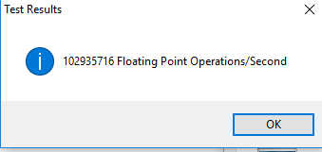

The second test ran for the CPU benchmark was the integer operations calculated per second by the CPU. In addition to the floating point operations calculated per second, by gauging the amount of integer operations calculated by the CPU, provides a more detailed view of the power and strength of the processor.

The integer operations calculated per second benchmark test yielded a result of 476,789,208 integer operations calculated by the CPU (figure 1.6). This result demonstrates the base power, strength, and speed of the processor by calculating millions of integer operations. Coupled with the results of the floating point operations calculated per second, the CPU benchmark test results demonstrates the overall strength, power, and speed of the processor.

**Figure 1.6**

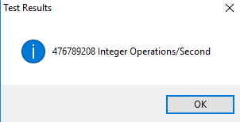

The third benchmark test rand on the CPU was the generation of MD5 hashes per second over a short amount of time. These results were previously utilized for the benchmark report regarding nested virtual machines. The test results successfully demonstrated a part of the overall strength and speed of the processor and was utilized to calculated trends of activity and performance by the CPU throughout the experiment.

The results of the benchmark test yielded in 1,319,338 MD5 hashes generated per second over a small amount of time (figure 1.7). This result, along with the results of the floating point and integer operations calculated per second benchmark tests, further details of the power, strength, and speed of the host system CPU when it is not being challenged by running a virtual machine on either hypervisor within the experiment.

**Figure 1.7**

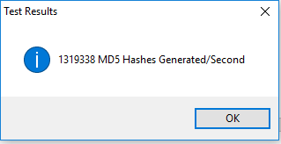

GPU Benchmark:

The host system had its GPU benchmarked in order to gauge the overall performance of the system and to see if the graphics card could perform under pressure and be able to carry over to the virtual machines. The GPU benchmark was carried out by the NovaBench benchmarking program that was used in the previous virtualization experiment. In order to benchmark the performance of the graphics card within the system, a benchmark test of generating a 3D environment and calculation of the amount of 3D frames generated per second by the GPU was carried out.

The results of the benchmarking test were that 1362 3D frames were generated per second throughout the 3D environment generation (figure 1.8). This result is key towards understanding the base performance of the GPU and how powerful and fast it is when pushed to certain limits. This gives a gauge in the overall performance of the system by forcing the graphics platform to generate 3D environments and push it to its limits. With the GPU being benchmarked, an overall calculation of performance of the system can be made when coupled with the results of other benchmark tests.

**Figure 1.8**

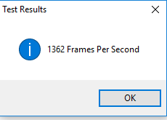

RAM Transfer Speed:

The host system’s RAM was benchmarked by NovaBench’s RAM transfer speed benchmark test. In reminiscence to the prior experiment with virtualization, the RAM transfer speed is utilized in gauging RAM speed, power, and latency across virtualization and host environments.

The result of the benchmark test was that the RAM transfer speed was 7884 MB per second (figure 1.9). These results give a detailed gauge of the overall memory functionality and power. The results of the RAM transfer speed test will be utilized to gain a baseline of the host’s performance and will be used in order to compare performance results across machines and states while running the hypervisors.

**Figure 1.9**

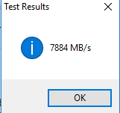

Hard Disk Drive Write Speed:

The hard disk disk drive was benchmarked by NovaBench’s HDD wirte speed benchmark test in order to guage the overall performance and speed of the HDD while writing data to a folder on the host system. This test is crucila to the overall result and overview of the host system’s performance, because it guages the performance of the hard disk drive while the host system performs other tasks simultaneously. With a higher write speed, the hard disk drive is proven to be more efficent and powerful when writing data and perfoming other tasks on the host system.

The results of the benchmark test revealed that the hard disk drive’s write speed was 169 MB per second (figure 1.10). With this result, a base comparison can be made to the various states of the host system before and during the virtualization process. This comparisson will be utilized to demonstrate not only a part of the gauge of the overall performance of the system, but also the performance of the hard disk drive before and during virtualization within the type 2 hypervisors.

**Figure 1.10**

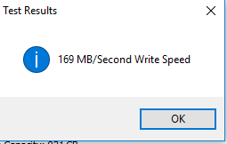

Ping Test Results:

The host system had another metric that was tested in order to get a more well-rounded calculation of the overall performance and status of the system, the network layer and its speed and latency. In order to gauge and benchmark the network layer of the host system, a ping and speed test was conducted and calculated by the website, [www.speedtest.net](http://www.speedtest.net). The results of this test revealed the ping/ latency, and download and upload speeds of the network connection when ran in its current status.

The results of the ping and speed test were that a ping of 10ms was detected, along with a download speed of 32.44 Mbps, and an upload speed of 3.42 Mbps (figure 1.11). These results demonstrate the overall strength and latency of the network layer of the host system without virtualization occurring. These results can be utilized for comparison to states of the host system before and while virtualization in order to make a more detailed and concrete review of network performance of the system.

**Figure 1.11**



**Virtual Box Virtual Machine Status and Benchmarking:**

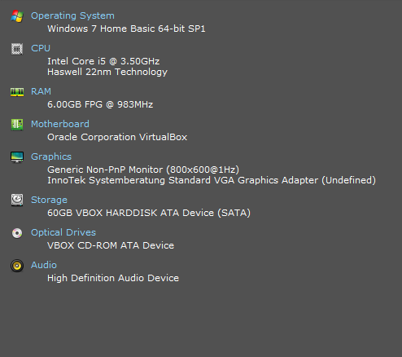

CPU Benchmark:

The CPU of the Windows 7 64-bit virtual machine within the Virtual Box hypervisor was benchmarked and the results of the tests were recorded accordingly. The CPU was benchmarked in order to note any system performance differences of the virtual machine in comparison to the host system and the virtual machine being ran within the VMware Workstation hypervisor.

The CPU was benchmarked accordingly, similar to the host system, by running and analyzing the results from tests on floating point and integer operations calculations per second and MD5 hash generation per second over a small period of time. These tests serve to test and measure the performance and efficiency of the CPU while under pressure.

The first test consisted of floating point operations calculated per second by the CPU. The result of the test was that the CPU was able to calculate 24,276,759 floating point operations per second (figure 2.1). This demonstrates the strength and efficiency of the CPU for it to be able to calculate over 24 million floating point operations per second over a very short time span.

In comparison to the results of the host system’s results, which was over 102 million floating point operations calculated per second, the virtual machine’s CPU is able to calculate 78,658,957 less floating point operations per second over a small time span. This shows that the CPU’s performance is very different than the performance of the CPU of the host system without any virtualization occurring. A decrease in performance of the CPU could be concluded from these results, or that the results are a sign that the CPU is strained and a select size of power and processing is delegated to the virtual machine through this hypervisor.

**Figure 2.1**

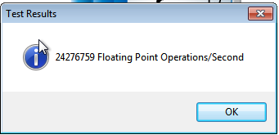

The second test ran to benchmark the virtual machine’s CPU was the calculation of integer operations per second over a small time span. This, in combination with the results of the floating point operation calculations by the CPU further demonstrates the overall CPU strength and performance within the virtual machine within the Virtual Box hypervisor.

The result of the benchmark test was that 59,262,642 integer operations were calculated per second over a small time span (figure 2.2). These results demonstrate the strength of the CPU in very much the way that the calculation of floating point operations by the CPU is relevant towards gauging CPU performance and strength within the hypervisor.

The result of the benchmark test yielded a difference in calculation of integer operation per second than that of the host system’s calculations. The difference between the host system’s results and the virtual machine’s results within Virtual Box is 417,526,566 less integer operations calculated per second. This is a very clear indication of performance difference than the host system and can act as tell-tale signs (when coupled with the result difference of the floating point operations benchmark test), that the CPU’s performance is much lower when running the virtual machine within the Virtual Box hypervisor than the performance of the CPU when ran by the host system without virtualization occurring.

**Figure 2.2**

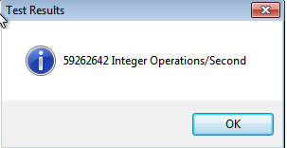

The third and final benchmark test ran on the virtual machine’s CPU while being ran within the Virtual Box hypervisor, was the MD5 hash generation test. The results of the test, together with the results of the two other benchmark tests, gives a more complete picture of the overall CPU performance and strength of the virtual machine within the Virtual Box hypervisor.

The result of the benchmark test resulted in 642,980 MD5 hashes generated per second (figure 2.3). This result, along with the results of the other CPU benchmark tests, give a more complete picture of the CPU performance of the virtual machine within the Virtual Box hypervisor.

The virtual machine’s MD5 benchmark result was 676,358 less than the amount of MD5 hashes generated per second than by the host system without virtualization occurring. This is a significant drop in CPU performance and further details how different the CPU’s performance is within the hypervisor. Together, along with the other three CPU benchmark tests, a clearer determination can be made that the CPU’s performance is marginally lower within the virtual machine when rand in the Virtual Box hypervisor, in comparison to the CPU being benchmarked within the host system without virtualization occurring.

**Figure 2.3**

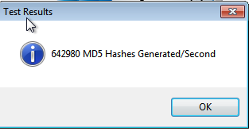

GPU Benchmark Results:

Unfortunately for the experiment, the GPU could not be benchmarked regarding the virtual machine’s graphical ability and limits within the Virtual Box hypervisor. This error is due to the makeup of Virtual Box which is limited as a hypervisor and requires special coding and enhancements in order for the GPU to be located and utilized for the benchmark test.

As it currently stands, due to this error, the GPU cannot be benchmarked or tested within Virtual Box. The meaning of this error and delay in the experiment is that virtual Box is lacking as a type 2 hypervisor. Although other metrics can be tested through the hypervisor, the GPU benchmark is a crucial metric that requires testing not only in regards to the experiment, but also in order to fully gauge and test the overall performance of the virtual machine and the hypervisor that runs it.

RAM Transfer Speeds:

Like the host system, the virtual machine’s RAM latency and strength was benchmarked through the RAM transfer speed test. This speed test further gauges the virtual machine’s performance through the Virtual Box hypervisor and gives a thorough description of how memory is handled both by the virtual machine and by the hypervisor that runs it.

The result of the RAM transfer test was that 3536 MB per second was transferred from the RAM (figure 2.4). This result, coupled with the CPU benchmark results further gauge the performance of the virtual machine and demonstrates the overall ability and performance of the Virtual Box hypervisor.

In comparison to the host system’s performance and the RAM transfer speed of the virtual machine within the hypervisor, a decrease of 4348 MB per second is detected. This further supports the notion that the virtual machine’s performance and ability is limited in comparison to the performance of the host system without virtualization occurring.

**Figure 2.4**



Hard Disk Drive Write Speed:

The hard disk drive’s write speed of the virtual machine was benchmarked and tested in order to detect any difference in performance. The results of the benchmark test were that the hard disk drive was able to write 96 MB per second (figure 2.5). this is a decrease of 73 MB per second than the write speed of the host system’s hard disk drive. This difference is significant to the overall results and review of the hypervisor’s performance because it further demonstrates the lack of performance of the virtual machine when ran within the Virtual Box hypervisor than the host system’s performance without virtualization occurring.

**Figure 2.5**

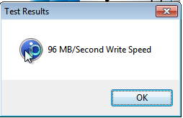

Ping Test Results:

The network speed and latency of the virtual machine within the Virtual Box hypervisor was tested and recorded accordingly to aid in determining the overall performance and differences of the hypervisor. In order to test and record the network strength and latency, a test was commenced through speedtest.net. With the results a detailed review can be made in differences in network performance of the hypervisor.

The results of the network benchmark test were that a ping of 9ms, download speed of 33.65 Mbps, and upload speed of 3.48 Mbps, was detected within the virtual machine (figure 2.6). These results, when compared to the results of the host system, is different in latency and speed. In comparison to the host system, a decrease of 1ms of ping is detected, along with a gain in download speed of 1.21 Mbps, and a gain of 0.06 Mbps in upload speed. The ping difference is not too critical in difference but the minor increases in upload and download speeds are a sign of network performance difference from the virtual machine and the host system without virtualization occurring.  
**Figure 2.6**



**VMware Workstation Virtual Machine Status and Benchmarking:**

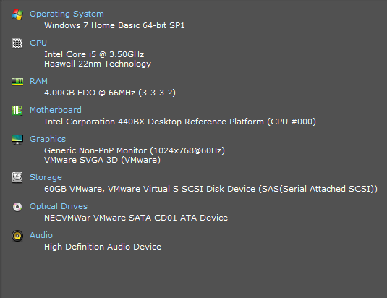

CPU Benchmarking:

The CPU of the Windows 7 virtual machine was benchmarked and recorded in order to help determine overall performance difference and limits of the virtual machine within the VMware Workstation hypervisor. In order to gauge the performance and strength of the CPU of the virtual machine within the hypervisor, three tests were running in order to test and record the ability of the CPU to perform under pressure.

The results of the first benchmarking test, which tested the virtual machine’s CPU performance while calculating floating point operations per second over a small time span, is key towards understanding the overall performance of the CPU of the virtual machine within the hypervisor. The CPU was able to calculate 23,583,376 floating point operations per second (figure 3.1).

This result was 79,352,340 less floating point operations calculated per second than the host system without virtualization. This difference helps detail the difference in performance of the CPUs of the host system and virtual machine. In comparison to the results of the Virtual Box benchmark tests, a decrease of 693,383 floating point operations calculated per second is evident. This can be possibly attributed to a slew of factors, but from the information gathered from the results of the virtual machine within the Virtual Box hypervisor, more floating point operations were calculated per second than those calculated by the CPU of the virtual machine within the VMware workstation hypervisor.

**Figure 3.1**

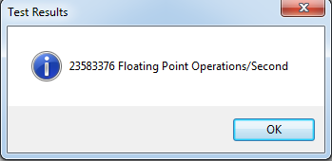

The second benchmark test conducted and recorded was based on the amount of integer operations calculated per second by the CPU. The results of the benchmark test further detailed the overall performance of the CPU within the VMware hypervisor.

The CPU was able to calculate 52,586,653 integer operations per second (figure 3.2). This result is compared to the host system, where there is a difference of 424,202,555 integer operations calculated per second. This is a significant loss in calculation of integer operation than the host system when no virtualization is occurring. In comparison to benchmark results of the virtual machine within the Virtual Box hypervisor, a difference of 6,675,989 integer operations calculated per second is apparent. This further details the difference of the performance of the CPU within the two hypervisors and help determine which is more powerful in CPU performance.

**Figure 3.2**

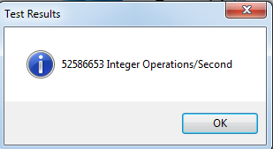

The third and final benchmark test ran on the CPU of the virtual machine within the VMware hypervisor is the generation of MD5 hashes per second. This further helps determine the CPU performance and strength within the hypervisor and is key towards producing a solid comparison between hypervisors and the host machine and virtual machine.

The result of the test yielded 486,987 MD5 hashes generated per second (figure 3.3). When compared to the results of the host system, a difference of 832,351 MD5 hashes generated per second is apparent. This demonstrates how there is a difference in performance of the CPU in comparison to the host system without virtualization and the virtual machine within the VMware hypervisor. In comparison to the benchmark results of the Virtual Box hypervisor, a difference of 155,993 MD5 hashes generated per second is apparent. This further supports the difference in CPU performance of the virtual machine within the hypervisors, and possibly helps prove the notion that the hypervisor to which the virtual machines are ran on, are key in that performance difference.

**Figure 3.3**

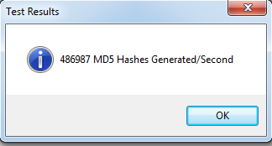

GPU Benchmark Results:

The GPU of the virtual machine within the VMware hypervisor was benchmarked and the results recorded in order to help gauge the overall performance of the virtual machine within the hypervisor. The results of the GPU benchmarking test detail the differences in performance and strength of the GPU between the host and the virtual machine, and the abilities of the hypervisors.

The benchmark test resulted in the GPU rendering 1705 3D frames per second while rendering a 3d environment (figure 3.4). This is different to the host system’s GPU benchmark by a gain of 343 more 3D frames rendered per second. This is actually amazing and provides a bit of a change in results where the GPU performance was actually greater than the host system without virtualization. In comparison to the Virtual Box hypervisor, the VMware hypervisor is able to benchmark the GPU and to recognize assets and perform from the graphics card of the host’s hardware setup. This is a stark difference in overall performance of the hypervisors and is key in evaluating the two overall.

**Figure 3.4**

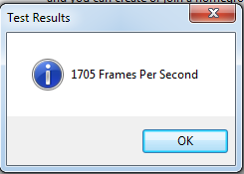

RAM Transfer Speed:

The RAM of the virtual machine within the VMware hypervisor was benchmarked and results recorded in order to detect difference across hypervisors and machines. The results of the RAM transfer speed benchmark demonstrated the strength and latency of the Ram across the hypervisor and is key towards understanding the performance of memory across the hypervisors and the machines.

The result of the benchmark test was that 3121 MB per second was transferred (figure 3.5). This helps gauge the memory performance of the virtual machine within the hypervisor and is key towards determining a difference in performance. In comparison to the host system with no virtualization occurring, a difference of 4763 MB per second is evident. This supports the notion that there is a performance difference between the host and the hypervisor. In comparison to the benchmark results of the Virtual Box hypervisor, a difference of 415 MB per second is apparent in the RAM transfer speed. This further aid the notion that there is a difference in performance in hypervisors and that less memory is transferred in the VMware hypervisor than the Virtual Box hypervisor.

**Figure 3.5**



Hard Disk Drive Write Speed:

The hard disk drive writing speed of the virtual machine within the VMware hypervisor was successfully benchmarked and recorded in order to help gauge the performance of the virtual machine in the hypervisor and to determine the difference across machines and hypervisors. The result of the benchmark is crucial to this evaluation and will help determine the performance difference between the hypervisors.

The result of the hard disk drive write speed benchmark test was 66 MB per second (figure 3.6). In comparison to the host system’s benchmark results without virtualization occurring at the time, a 103 MB per second difference is evident. With this difference in drive write speeds between the host and the virtual machine, it can be determined that the host system had better drive write speed performance than the virtual machine’s. In comparison to the Virtual Box hypervisor’s benchmark results, a 30 MB per second difference is apparent. This difference help supports the notion that there is a difference in performance between the two hypervisors, and additionally aid the notion that the Virtual Box hypervisor has better hard disk drive writing speed performance than the performance of the virtual machine within the VMware hypervisor.

**Figure 3.6**

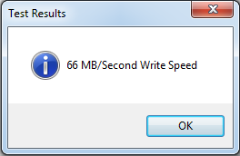

Ping Test Results:

The network speed and latency was benchmarked and tested within the VMware hypervisor and the results were recorded in order to compare the network benchmark results with those of the host system and the other hypervisor. The results of this benchmark test, helps gauge the overall performance of the virtual machine in the VMware hypervisor and helps determine the difference in performance of the hypervisors.

The benchmark test revealed that the ping of the network was 9 ms, a download speed of 85.41 Mbps, and an upload speed of 3.38 Mbps (figure 3.7). In comparison to the benchmark results of the host system with no virtualization occurring, there is a difference of 1 ms in ping, a gain of 52.97 Mbps in download speed, and difference of 0.04 in upload speed. In comparison to the results of the Virtual Box hypervisor, the ping is the same amount, and the download speed of the VMware hypervisor is 51.76 Mbps more, and the upload speed is 0.10 Mbps less than the Virtual Box hypervisor. These differences between the hypervisors show that both have the same amount of network latency, and reveal that the VMware hypervisor has greater download speeds and lesser upload speed. This further demonstrates the overall difference of the hypervisors and allows for the experiment to be successfully evaluated between the hypervisors’ performance.

**Figure 3.7**



**Host System Benchmarking and Status (While running Virtual Box):**

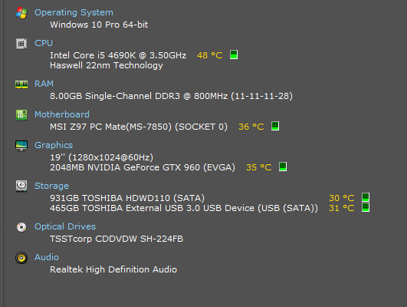

CPU Benchmark:

In order to compare the results of the states of the host system before and during the virtualization process of a virtual machine through the Virtual Box hypervisor, the various benchmark tests that were conducted before on the host system must be repeated to detect difference in performance. The CPU benchmark tests that were rand were identical to the tests ran on the host system before the use of virtualization, and the differences in results should be utilized in order to make a more educated review of the performance differences of the hypervisors and their effects on the host system.

The floating point operations calculations benchmark test was conducted on the host system while it ran the Virtual Box hypervisor, and the results from is to be used in comparison to the state of the host system prior to the use of virtualization. The results from the floating points operations benchmark test was that 102,882,952 floating point operations were calculated per second (figure 4.1). The difference to the state of the host system before virtualization is 52,764 less floating point operations calculated per second. This can be partly due to the CPU also being accessed and ran on the Virtual Box server which had significantly lower results.

**Figure 4.1**

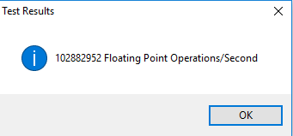

The second CPU test conducted on the host system focused on how many integer operations could be calculated per second. The results of this test additionally help evaluate the difference in performance and effect of the hypervisors on the host system.

The result of the benchmark test was that 469,738,232 integer opreations calculated per second (figure 4.2). In comparison to the results of the host system before the use of virtualization, was a difference of 7,050,976 integer operations calculated. This is lower than the amount of integer operations calculated by the host system prior to the use of virtualization. This also adds to the notion that the CPU performance is different within the host system in comparriosn to its original state.

**Figure 4.2**

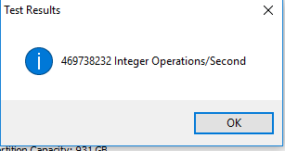

The third and final CPU benchmark test conducted on the host system was the MD5 hash generation test. By generating a number of MD5 hashes per second over a small time span, the CPU performance can be successfully being benchmarked and gauged in combination with the results of the other benchmark tests.

The result of the benchmark test was that 1,307,495 MD5 hashes generated per second (figure 4.3). In comparison to the original state of the host system, a difference of 11,843 MD5 hashes generated per second is evident. This decrease in MD5 hashes generated per second, coupled with the other results of the other CPU benchmark tests, further supports the notion that there is a CPU performance decrease during virtualization occurring on the host system level.

**Figure 4.3**

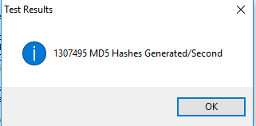

GPU Benchmark Results:

The GPU of the host system was benchmarked once more in order to help detect performance differences and issues that may occur while virtualization occurs. The results of the GPU benchmark help decide the overall performance difference of the different states of the host system before and during the virtualization process and to see if the Virtual Box hypervisor changes performance accordingly.

The result of the GPU benchmark test was that 1387 3D frames were rendered per second (figure 4.4). When compared to the original state of the host system and the GPU benchmark results of the time, an increase of 25 3D frames are generated per second. This could be possibly due to Virtual Box lacking the ability to benchmark and connect the host system’s GPU, thus resulting in better, or even potentially similar, benchmark results for the host system GPU.

**Figure 4.4**

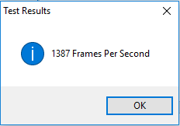

RAM Transfer Speed:

The RAM transfer speed of the host system while running the Virtual Box hypervisor is benchmarked and analyzed in order to compare the states of the host system and the RAM performances. The results of this benchmark help further gauge a complete evaluation of performance differences between the states of virtualization and no virtualization of the host system, and is key in evaluating the performance of the hypervisor and its effects on the host system.

The benchmark test resulted in the RAM transfer speed being 7578 MB per second (figure 4.5). When compared to the original state of the host system, a difference of 306 MB per second is apparent. This difference in RAM transfer speed does support the notion that the host system’s performance is lower while virtualization occurs and that the hypervisor does have an effect on overall performance of the host system as well.

**Figure 4.5**

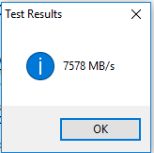

Hard Disk Drive Write Speed:

The hard disk drive speed of the host system was benchmarked and used in order to compare the results of the prior and current stages of the host system. With these results, a more complete evaluation can be made as to what degree the hypervisor has an effect on the hardware performance of the host system.

The result of the hard disk drive writing speed benchmark test was that the disk was able to write 76 MB per second (figure 4.6). In comparison to the prior state of the host system without virtualization occurring, a difference of 93 MB per second is evident between the two write speeds. This further supports the notion that there is an overall performance difference of the host system’s hardware before and while virtualizing a virtual machine through the use of a hypervisor.

**Figure 4.6**

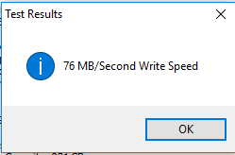

Ping Test Results:

The internet speed and latency test was ran and calculated on the host system to detect performance difference within the network layer. The results of this test will help solidify the overall effect of the Virtual Box hypervisor on the host system and any performance differences it causes.

The results of the benchmark test were a ping of 10 ms, a download speed of 32.62 Mbps, and an upload speed of 3.37 Mbps (figure 4.7). In comparison to the results of the host system prior to virtualization, the was no change in latency through the ping, a gain in download speed of 0.18 Mbps, and a difference of 0.05 Mbps in download speed. This demonstrates that here isn’t much of a difference in network performance of the host system while running the Virtual Box hypervisor. With those results, it can be concluded that the Virtual Box hypervisor has minimal impact on the network performance of the host system.

**Figure 4.7**



**Host System Status and Benchmarking (While Running VMware Workstation):**

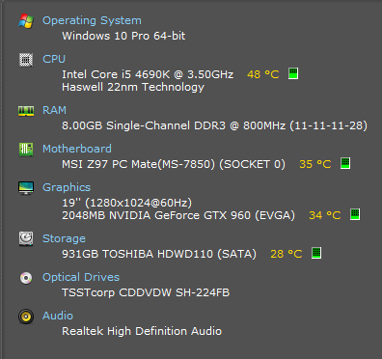

CPU Benchmark:

The CPU of the host system was benchmarked in order to detect performance differences of the CPU as effected by the VMware hypervisor running on the host system. In order to successfully evaluate performance differences and the effects of the hypervisor on the CPU, the three CPU benchmark tests that were ran on the host system originally, must be ran on the host system in its current state and its results recorded for analysis.

The first benchmark test ran on the host system was the calculation of floating point operations per second. The results of this benchmark test helps initially gauge the CPU performance of the host system while the VMware hypervisor runs, and how the performance changes between states of virtualization and which hypervisor is ran on the host system.

The result of the benchmark test was 102,865,116 floating point operations calculated per second (figure 5.1). In comparison to the results of the host system prior to virtualization, a difference of 70,600 floating point operations calculated per second is to be observed. This further supports the notion that performance does differ between states of virtualization and that the host system performs differently while virtualization occurs. In comparison to the host system’s results while running the Virtual Box hypervisor, a difference of 17,836 floating point operations calculated per second by the CPU is apparent. This demonstrates that the Virtual Box’s effect on the host system is different than the effect of the VMware hypervisor on the host system, and that the CPU performs differently accordingly to the hypervisor running on the host system.

**Figure 5.1**

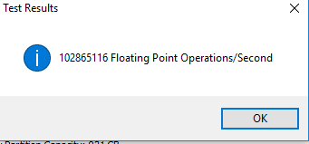

The second CPU benchmark test determined how many integer operations calculated per second by the CPU. With the results of the benchmark test, further evaluation can be made in the differences in CPU performance of the host system between states of virtualization and which hypervisor is used.

The result of the benchmark test was 468,002,524 integer operations calculated per second (figure 5.2). In comparison to the original state of the host system, a difference of 8,786,684 integer operations calculated per second becomes apparent. This, in combination to the prior CPU benchmark test result, also further supports the notion that CPU performance differs and is less when virtualization occurs. In comparison to the host system state when Virtual Box hypervisor was being used, a difference of 1,735,708 integer operations calculated per second is evident. This difference in results help support the notion that CPU performance is different between the two hypervisors, and that the Virtual Box hypervisor has a lesser effect on the host system’s CPU performance than the use of the VMware hypervisor.

**Figure 5.2**

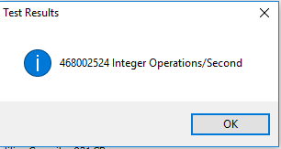

The third and final CPU benchmark tested on the host system while using the VMware hypervisor was the generation of MD5 hashes generated per second. The result from this benchmark test, in combination to the results of the other CPU benchmark tests, give a clearer and concise picture of the performance in differences of the CPU between the states of the host system while using ether hypervisors.

The result of the benchmark test was 1,300,708 MD5 hashes generated per second (figure 5.3). In comparison to the results from the host system prior to virtualization, there is a difference of 18,630 MD5 hashes generated per second. This difference supports the notion that the CPU performance does change during virtualization and is considerably lower than CPU performance without virtualization occurring. In comparison to the results of the host system while using the Virtual Box hypervisor was a difference of 6787 MD5 hashes generated per second. The difference in the benchmark tests helps solidify the notion that the CPU has performance differences on the host level depending on the hypervisor being used at the time. With those results, it can be concluded that the Virtual Box hypervisor has a lesser impact on CPU performance on the host system and better performs than the effect of the VMware hypervisor on the host system.

**Figure 5.3**

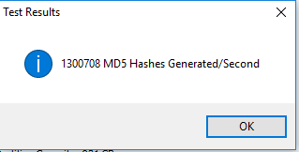

GPU Benchmark Results:

The GPU of the host system was benchmarked in order to detect performance differences between states of virtualization and the use of the hypervisor on the host system. The results of the benchmark test help evaluate the hardware effects of the hypervisors on the host system and which hypervisor has a different effect on GPU performance.

The result of the benchmark test was that 1350 3D frames rendered per second (figure 5.4). In comparison to the results of the original state of the host system, there was a difference of 12 frames per second. This marginal difference does help support the notion of performance difference between states of virtualization on the host system. In comparison to the results of the host system while using the Virtual Box hypervisor, there was a difference of 37 frames per second rendered. This supports the notion that there are performance differences of the host system according to the hypervisor being used. It should be noted, although the comparison of the hypervisors effect on the host system does depict the host system while using Virtual Box has higher 3D render frame rate, the reasoning behind this difference is due to the Virtual Box’s lack of ability to utilize and benchmark the system’s GPU. So the results do favor the Virtual Box hypervisor’s results, but at the price of the hypervisor not being able to support the system GPU, thus giving a different result in performance.

**Figure 5.4**

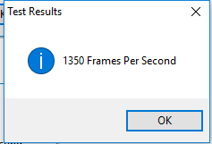

RAM Transfer Speed:

The RAM transfer speed of the host system while using the VMware hypervisor was compared to the states of the host system through virtualization and the use of a hypervisor. The results from this benchmark test will help determine the memory latency and strength of the host system across the states of performance and demonstrate the various effects of the hypervisors on the host system’s RAM.

The result of the RAM transfer test was 7253 MB per second (figure 5.5). In comparison to the results of the host system prior to virtualization, there was a difference of 631 MB per second. This difference of RAM transfer speed further proves that there is a hardware performance difference across states of virtualization, and a lesser result of performance during virtualization I comparison to a state without virtualization occurring. In comparison to the results of the host system while using the Virtual Box hypervisor, there was a difference of 325 MB per second in the RAM transfer speed. This further proves that the Virtual Box hypervisor has a lesser impact on hardware resources of the host system.

**Figure 5.5**

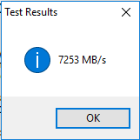

Hard Disk Drive Write Speed:

The hard disk drive write speed of the host system was benchmarked to analyze the difference in performance of the write speed depending on the state of virtualization and which hypervisor is being used. With this test result, a more complete gauge can be made on the effect of hardware performance while running the VMware hypervisor, and how it defers from the default state of the host system, and the effects of the Virtual Box hypervisor being used.

The result of the benchmark test was 103 MB per second written (figure 5.6). In comparison to the results of the host system without virtualization occurring, there was a difference of 66 MB written per second. This helps prove hard ware performance difference between virtualization states of the host system. In comparison to the results of the host system while using the Virtual Box hypervisor, there was actually an increase of performance of 27 MB written per second by the VMware hypervisor being used. This becomes a change in the trend of performance effects of the hypervisors on the host system. With this difference in write speeds, it can be determined that the VMware hypervisor utilizes less of the host system’s hard disk drive, and has a lesser impact on the overall performance of the host system’s hard ware while running the VMware hypervisor.

**Figure 5.6**

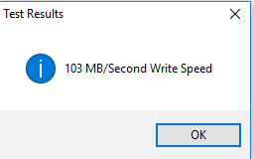

Ping Test Results:

The network layer of the host system was benchmarked and tested through an internet speed and latency test. With the results of this test, it a clearer conclusion can be made of the hypervisor’s effect not only on the network layer of the host system, but also the overall performance of the host system.

The results of the benchmark test were a ping of 7 ms, a download speed of 32.46 Mbps, and an upload speed of 3.42 Mbps (figure 5.7). In comparison to the results of the host system prior to virtualization, there was a difference of 3 ms in ping, a gain of 0.02 Mbps of upload speed, and a consistent upload speed. These results show that the VMware hypervisor has an effect which lowers the latency through the ping, but an increase in download speed and a consistent upload speed value. In comparison to the results of the host system while using the Virtual Box hypervisor, there was a 3 ms difference in ping, a difference of 0.16 Mbps in download speed, and a gain of 0.05 Mbps in upload speed. The latency of the network is certainly lower in comparison to the results of the host system while using Virtual Box, and the download speed was additionally higher, but the upload speed of the host system while using the VMware hypervisor is higher. This demonstrates that the Virtual Box hypervisor has a lesser impact on network performance of the host machine and is more reliable and faster than the results of the host system while using the VMware hypervisor.

**Figure 5.7**



**Analysis and Comparison of Results:**

From the results gathered from the various benchmarks conducted on the various metrics both on the host system and the virtual machine within the hypervisors, a more concrete analysis can be made in order to evaluate the differences in performance of the hypervisors and their effect on the host system. These results are key in understanding the overall effect and performance changes the hypervisors have both on the virtual machine and the host system.

The CPU benchmark tests were used to gage the overall effect of the hypervisors on the CPU performance both within the virtual machine and within the host system. The results of the benchmark tests were that the Virtual Box hypervisor had a larger use of the CPU and higher results calculated and generated by the CPU than the results from the VMware hypervisor CPU benchmark tests. With these results, it can be concluded that the Virtual Box uses more CPU resources, as well has a bigger impact on the host system’s CPU than the VMware hypervisor. Thus, the Virtual Box uses more CPU power, but lacks efficiency that VMware hypervisor has.

The GPU benchmark help demonstrate a key difference between the two hypervisors. The Virtual Box hypervisor was not able to run GPU benchmarks due to a lack of ability to connect the host system’s GPU through to the virtual machine. As a result, the GPU could not be benchmarked, and the effect on the host system yielded a higher render frame rate than the host system while running VMware. The VMware hypervisor was able to render 1703 3D frames per second. This is significant and demonstrates the functionality and versatility of the VMware hypervisor, where more of the host system’s resources is utilized and gives a more detailed and well-built virtual machine.

The RAM transfer speed benchmark helped demonstrate the difference in performance of RAM across the machines and the hypervisors. The results of the benchmark tests revealed a lead in RAM transfer speed by the virtual box hypervisor and a greater use of RAM from the host system. This helps conclude that Virtual Box uses more memory, but at the cost of utilizing more of the host system’s memory, thus effecting the performance of the host system.

The hard disk drive speeds were benchmarked and compared in order to help determine the overall impact of the hypervisors on the system’s hardware. The results of the benchmark tests revealed a greater write speed within the Virtual Box hypervisor. With this result, it can be concluded that the Virtual Box hypervisor uses more of the hard dis drive and is able to write data faster, thus helping the overall performance of the virtual machine.

The final benchmark test ran on the machines within the hypervisors and the host system was the internet speed and latency benchmark tests. The speed test revealed that both virtual machines were able to retain similar ping readings, but a greater download speed within the VMware hypervisor, and a higher upload speed within the Virtual Box hypervisor. It can be concluded with the results found that the VMware hypervisor utilizes more of the network layer of the host system and yields greater results with only a marginal difference in upload speed performance.

In consideration to the results of the metrics tested and benchmark tests ran, it appears that the Virtual Box hypervisor utilizes more system resources including software, while at the price of network performance and the use of a GPU. This can be used for power and strength of resources through the virtual machine. On the other hand, for a more complete and well-rounded performance by the virtual machine, the VMware hypervisor is a key component. The VMware hypervisor uses less system resources but allows GPU functionality and greater network performance. As a result, it can be concluded, that for system performance efficiency and balance across the host and virtual machine and better network performance and full functionality, the VMware hypervisor is ideal.

**Configuration Changes:**

In order to test the limits of the type 2 hypervisor, it was required to take a look at the configuration file of the virtual machine and understand how it works. In order to conduct this phase of the experiment, the choice was made to use the virtual configuration file generated by the virtual machine used on the VMware Workstation hypervisor. With changing and recording the performance difference, one can get a better understanding of the hypervisor and how it impacts performance.

The virtual machine configuration file was edited within Notepad where various values were changed and edited. Figure 6.1 details the original status of the configuration file and before edits are made to various values and entry fields.

First change made to the configuration file was the changing of values for the scsi0.preset and sata0.preset entry fields from “TRUE” to “FALSE” (figure 6.2).

**Figure 6.2**

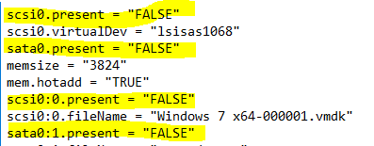

The results of that change resulted in a failure to boot for the virtual machine. The failure to boot was explained by the hypervisor, because the operating system was not found (figure 6.3).

**Figure 6.3**

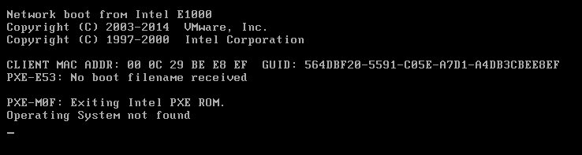

In order to determine the cause of this system failure, a trial by elimination must be made regarding the edits made on the configuration file. In order to do this, the sata0.present fields were reset to “TRUE”, while the scsi0.present fields remained “FALSE (figure 6.4).

**Figure 6.4**

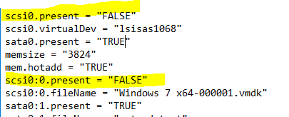

The results of the edit made to the configuration file was similar to the results before, where the virtual machine failed to boot dude to an error listed that no boot device was loaded and therefore the was no operating system found (figure 6.5).

**Figure 6.5**

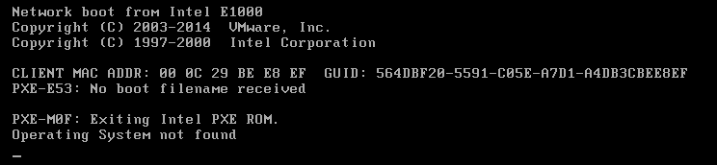

The next step in the process to nail down the cause of the failed booting of the virtual machine was to then reverse the values of the scsi0.present values from “FALSE” to its original value of “TRUE” (figure 6.6).

**Figure 6.6**

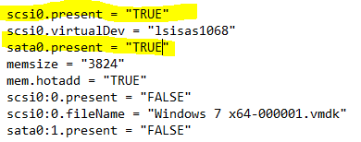

The effect of completely resetting the values to its original state which actually allowed it to boot up successfully and run again.

As a result of this trial and error process it can be concluded that the scsi0.present fields were key towards the booting of the operating system and with those values changed, the virtual machine would fail to load and operate.

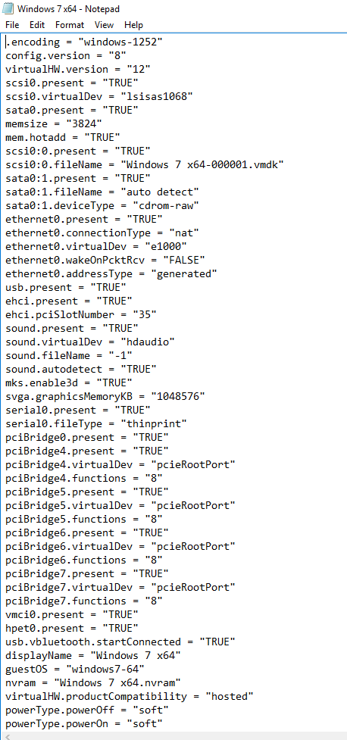

**Conclusion:**

In conclusion, there are key differences between the two type 2 hypervisors, VMware Workstation and Virtual Box, and how they affect performance of the virtual machine and the host system. The two hypervisors differ in functionality and how they affect the performance of the virtual machines and the host system that they are hosted on. Additionally, system resources are utilized in different ways in comparison to the two hypervisors and help generate different results.

From the results gathered and analyzed from the benchmark tests, a clear trend is observed where the Virtual Box hypervisor uses more system resources from the host system’s hardware and thus can result in high performance and strength in the virtual machine’s hardware. With this amount of usage of hardware resources of the host system by the hypervisor, the virtual machine’s CPU, RAM, HDD, and network layer yields greater performance and increased functionality and versatility of the virtual machine hosted within it. Unfortunately, this does come at a price, where the Virtual Box hypervisor lacks the ability to feature the host system’s GPU, thus making benchmarking impossible for it. Additionally, the network results were lower in latency to the results of the host system, and lower network results than the results from the VMware hypervisor.

On the other hand, the results from the benchmark tests revealed that the VMware hypervisor is able to use less system resources from the host system, and is able to utilize the host system’s GPU and yield greater network layer results that are even higher than the host system’s results. The VMware hypervisor could be used to run virtual machines in order to save system usage on the host system and could possibly lead to more virtual machines being able to be hosted on the hypervisor with less system degradation and effect on performance than that of the Virtual Box hypervisor. This hypervisor is key towards using virtual machines with greater network performance and maintain system resource efficiency.

Altogether the vote come down to the user and the particular use they would want to use virtual machines for. If the user wants greater system performance by the hardware provided, but at the cost of host system performance efficiency, then Virtual Box is the best choice for a type 2 hypervisor to host the virtual machine. Virtual Box will be able to utilize more resources from the hardware provided and can generate greater results and perform more tasks. If the user wishes to use their virtual machine with a regard in host system efficiency and usage, while utilizing greater network performance and GPU performance, then VMware Workstation hypervisor is a better choice. With the VMware hypervisor, the user is able to use more network resources and graphical resources. With the cost of overall hardware usage within the virtual machine, more functionality is available to the user and the host system’s resources are managed more efficiently.

In the end, there are many differences in performance and efficiency in the type 2 hypervisors tested within the experiment. With further testing and editing of the virtual machine’s configuration file, it can be determined which factors help break or keep the virtual machine running. With this testing, coupled with the information gathered from the benchmark tests, it can be concluded that the type 2 hypervisors try to utilize either system performance and strength or efficiency in a unique way. With Virtual Box more focused on power, more resources are used, but some features are lacking and network performance is lower. Whereas with VMware Workstation, efficiency is key and less hardware resources are used, thus resulting in lower hardware performance through the virtual machine, but network performance is greater and the hypervisor utilizes the GPU and possibly more resources than the Virtual Box hypervisor without additional add-ons or configuration. A type 2 hypervisor is versatile, and depending on the user’s preference for its virtual machines, a choice can be made between the two hypervisors mentioned. Both have key advantages and disadvantages which over all help create a well-rounded and complete experience through the virtual machine to suite whatever means or requirements of the user.